**Python Portfolio**

Contract Django Developer at Geniopay.com - 2/2022 to 6/2021

https://sandbox.geniopay.com

Skill-Set : Django , Stripe, Stich , Trello , Bootstrap5, SaaS

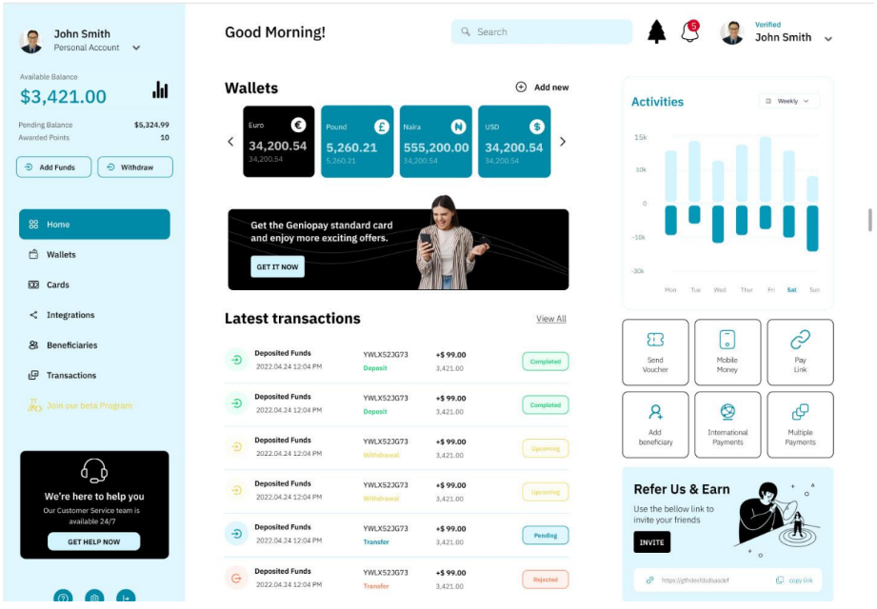

Contract Django Developer at GoOpenMichigan - 2/2016 to 12/2016

<https://goopenmichigan.org/>

Skill-Set: Django, Python, PostgreSQL, AWS EC2, S3

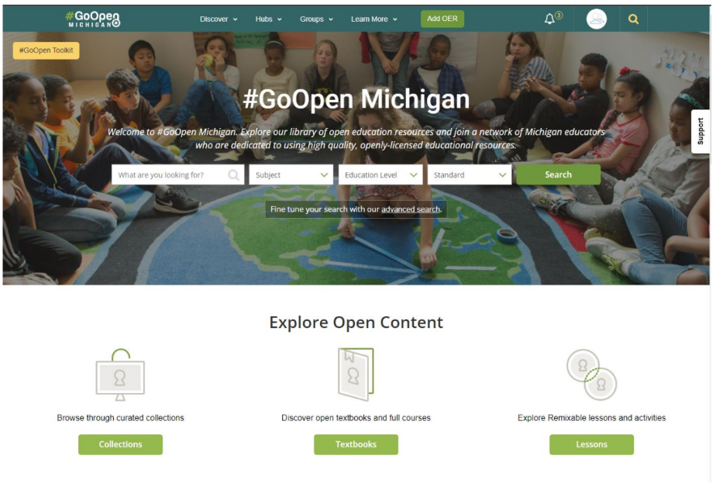

Contract Django Developer at GoOpenMichigan - 8/2020 to 05/2021

<https://skigit.com/>

Skill-Set: Django, Python, PostgreSQL, Docker

